**Online & Blended DEBATES**

There are three stages to any debate:

1. Debate topics as proposition statements & forming groups (teams)(taking sides)
2. The actual debate
3. Post-debate reflection/final product

**INSTRUCTOR DECISIONS**

Use various inputs, such as course level, learning outcome(s), mode of delivery, and your time allocation to guide making choices along a ‘low’ to ‘high’ spectrum for at least four categories:

**Group Work**

* It’s easier to work together in F2F mode of delivery
* Consider group exposure: to what extent is there an audience? (see* below)

**Research**

* Curated versus independent or collaborative

**Engagement**

* Expectations (intra-group and/or whole class)

**Outcome**

* Minimum: Reflection on learning
* Standard: Final position on the proposition statement
* Could be an essay
* Independent versus group submission

Also: fit in the course; #; sequential or concurrent

**LOW**

**HIGH**

**Groups**

**Outcome**

**Research**

**Engagement**

CC BY-NC 4.0

**Course Name:**

**Course Topic/Chapter/Lesson:**

**Identify Debate Topics and develop concise and controversial draft Proposition Statements**

1

2

3

4

5

Organize students into groups, share flowchart and rubric(s)



**See notes below:**

|  |  |  |
| --- | --- | --- |
| **Less work** | **More work** | **Moodle Work** |
| Create proposition statements and give them to the students | Open suggestions round; you turn ideas into proposition statements; students vote on most popular; then Group Choice | 1. Participants/Create Groups & Grouping (min 6-7 students), 2. Group Choice activity |
|  | Questionnaire tool |  |

**Groups**

**Choose one:**  Individual assignment Group assignment

**Choose one:**  Curated literature Students find literature

|  |  |  |
| --- | --- | --- |
| **If curated:** | **PRO sources** | **CON sources** |
| Debate topic 1 |  |  |
| Debate topic 2 |  |  |
| Debate topic 3 |  |  |
| Debate topic 4 |  |  |
| Debate topic 5 |  |  |

 Drop box; collect and grade research assignments



**See notes below:**

**Research**

|  |  |  |
| --- | --- | --- |
| **Independent** | **Collaborative** | **Moodle Work** |
| Individual | Group | Create a Moodle assignment drop box. |
| **Curated** | **Library Search** |  |
| Students read curated scholarly literary sources | Students find their own scholarly literary sources |  |
| Annotated bibliographies, literature reviews, etc. | |  |
| Options:   * Create a list/table with subordinate points and ‘pro’ and ‘con’ argument * Scaffolding (permalinks, what is scholarly evidence (…)) | |  |

**DEBATE STRUCTURE AND GRADING DECISIONS:**

Online, face-to-face (f2f), both? (A online, B online or A online, B f2f …)

How long will students debate? (one day for A, two days for B …)

How many words should student posts if online, how many minutes if f2f?

How will the grading work in the A and B parts of this debate? (Graded in a discussion forum; a form to copy and paste plus fill in and submit to a drop box after; a combination?)



**See notes below:**

**Engagement**

|  |  |
| --- | --- |
| **Steps A & B** | **Expectations & Decision Considerations** |
| **A**: Individual, required first post in the debate forum by X day at X am/pm.  Copy and paste proposition statement at the top of each post.  One 'pro' 150-word argument; one 'con' 150-word argument. Bibliography with hyperlinks. | If Q&A forum, please remind students that after they post, they can see others' posts in 45-minutes;  Students are not allowed to reply until B starts  Tip: one iteration of the debate design maximizes individual work with virtually no dependence on others for assessments. This was found to work best for online learning. It is nonetheless important to emphasize and incentivize group interaction in the actual debate. |
| **B**: Group engagement  Required to post, back and forth, starting at the same X day at X am/pm (when the Moodle helpdesk is open)  Reply to others at least 3 times within 12 hours; six times before the end | Make sure there is a penalty and it is clear that this is an event and when students are part of a group. Group members rely on one another.  **If face-to-face, invite students to share their final positions.** |

|  |  |  |
| --- | --- | --- |
| **Moodle setup task and decision** | | |
| Create the debate forum | If a QandA forum, post a question in the forum; include proposition statements | Tips for your discussion forum  Type: QandA  *Separate/Visible Groups  Forced Subscription  Opens 1 week before, closes at endpoint (48-hours later) |
| **Student guidance** | | |
| Post instructions, dates and deadlines | Student flowchart | Grading: in DF or form, break-down & rubric(s) |
| Explain the debate process | Make a video in the student view | BBB, in your Virtual Classroom, or, Kaltura |
| Create opportunities to learn skills:   * Posting to a QandA forum * Creating library article permalinks | Practice forum requiring a permalink. Give them the library research guide "Creating links to library resources" (https://libguides.tru.ca/links) | Practice Discussion Forum, type: QandA |

**How will you invite students to reflect and document what they learned?**

(An actual reflection, telling a story about the debate, and/or articulating a final position in the form of: an individual essay, blog post, e-portfolio, journal entry which includes debate statements …)

 Drop box; collect and grade reflection assignments



**See notes below:**

**Outcome**

|  |  |  |  |  |  |  |
| --- | --- | --- | --- | --- | --- | --- |
| **Sample Rubric** |  |  |  |  |  |  |
| **ONLINE DEBATES RUBRIC** | **Individual or Group** | **% of overall grade** | Exemplary | Accomplished | Developing | Emerging |
| **Research (and sub-issues)** |  | 30% | Demonstrates thorough investigation of debate topic. (…) |  |  |  |
| **Debate (?)** |  | 20% |  |  |  |  |
| **Reflection (+)** |  | 50% |  |  |  |  |
|  |  |  |  |  |  |  |
| **Your Rubric** |  |  |  |  |  |  |
| **ONLINE DEBATES RUBRIC** | **Individual or Group** | **% of overall grade** |  |  |  |  |
| **Research** |  |  |  |  |  |  |
| **Debate (?)** |  |  |  |  |  |  |
| **Reflection (+)** |  |  |  |  |  |  |

**Student Flowchart:**

Create a flowchart for your students, customizing the diagram on the left. You can then take a ‘photo’ (‘snip it’ on TRU desktops) and paste it in Moodle. (It’s a good idea to make a video for them as well.)

**Summary**

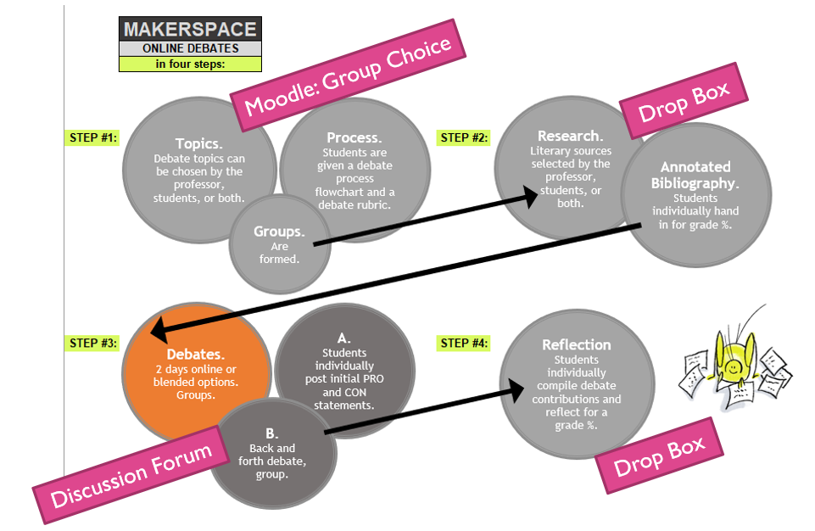



**Your Notes and/or Scholarly Teaching Practice Space**

**Scholarly Teaching phases**

Document

Reflect

Modify

(Please share 😊) Tip: <https://cricket.trubox.ca/>

Repeat